25 Days of Kindness

Hold the door open for someone  This Photo by Unknown Author is licensed under CC BY-ND | Sit by someone new at lunch  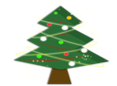  This Photo by Unknown Author is licensed under CC BY-ND | Tell a teacher how much you appreciate them  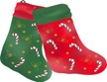  This Photo by Unknown Author is licensed under CC BY-ND | Make a new friend  This Photo by Unknown Author is licensed under CC BY-SA | Play with someone new at recess  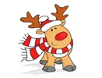  This Photo by Unknown Author is licensed under CC BY
Bring a treat to neighbors  This Photo by Unknown Author is licensed under CC BY-ND | Compliment someone at school  This Photo by Unknown Author is licensed under CC BY | Make someone smile  This Photo by Unknown Author is licensed under CC BY-SA | Tell a janitor you appreciate them  This Photo by Unknown Author is licensed under CC BY-ND | Tell a lunch worker you appreciate them  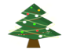  This Photo by Unknown Author is licensed under CC BY-ND
Ask someone if they need help with anything  This Photo by Unknown Author is licensed under CC BY-ND | Tell your friends how much you appreciate them  This Photo by Unknown Author is licensed under CC BY-ND | Call a loved one to tell them how much you love them  This Photo by Unknown Author is licensed under CC BY | Tell a teacher how much you appreciate them  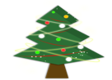  This Photo by Unknown Author is licensed under CC BY-ND | Put treats out for the delivery men and women  This Photo by Unknown Author is licensed under CC BY-SA
Send someone a kind letter  This Photo by Unknown Author is licensed under CC BY-SA | Random act of kindness  This Photo by Unknown Author is licensed under CC BY-ND | Make a homemade gift for someone  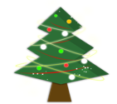  This Photo by Unknown Author is licensed under CC BY-ND | Give someone a hug  This Photo by Unknown Author is licensed under CC BY-ND | Offer to help with a chore  This Photo by Unknown Author is licensed under CC BY
Make someone smile  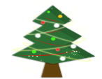  This Photo by Unknown Author is licensed under CC BY-ND | Offer to help someone out  This Photo by Unknown Author is licensed under CC BY | Random act of kindness  This Photo by Unknown Author is licensed under CC BY-SA | Donate toys  This Photo by Unknown Author is licensed under CC BY-ND | Random act of kindness  This Photo by Unknown Author is licensed under CC BY-ND
This Photo by Unknown Author is licensed under CC BY-ND

