February 17, 2015

Dear Gwyneth,
Hooray! You lost your FIRST tooth! You are growing up so fast and becoming quite the little lady. I had a fun time flying around your room tonight as you slept and I hope that you like the little surprise I left for you. Thank you for leaving the little tooth pouch for me to find your tooth in! It made it so much easier than searching for a tiny tooth under your pillow.
I hope you keep smiling bright and remember to brush and floss those teeth every day. You want to keep them sparkly!
Love,
The Tooth Fairy
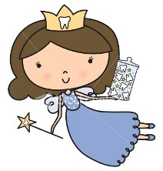
February 17, 2015
Dear Gwyneth,
Hooray! You lost your FIRST tooth! You are growing up so fast and becoming quite the little lady. I had a fun time flying around your room tonight as you slept and I hope that you like the little surprise I left for you. Thank you for leaving the little tooth pouch for me to find your tooth in! It made it so much easier than searching for a tiny tooth under your pillow.
I hope you keep smiling bright and remember to brush and floss those teeth every day. You want to keep them sparkly!
Love,
The Tooth Fairy

